Internship Report - Day 1
Name : Rickshtiha A
Intern ID : CDM/INT/202607608
Objective
Set up the development environment and understand the basics of AI, Machine Learning, and Data Science.
Tasks Completed
- Installed Python.
- Installed Visual Studio Code (VS Code).
- Installed Jupyter Notebook.
- Installed Git.
- Learned the basics of Artificial Intelligence (AI), Machine Learning (ML), and Data Science (DS).
- Created a GitHub repository
- Created and executed the first Python program.
- Uploaded the project files to GitHub.
First Python Program
print("Hello, World!")
print("My name is Rickshitha")
print("Welcome to AI Internship")
Output
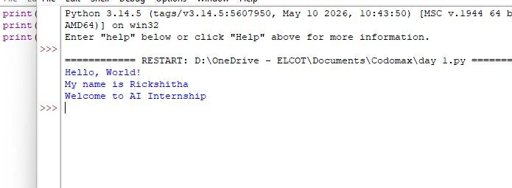
Learning Outcome
The development environment was successfully configured. Basic knowledge of AI, ML, and Data Science was gained, GitHub was set up, and the first Python program was executed successfully.
